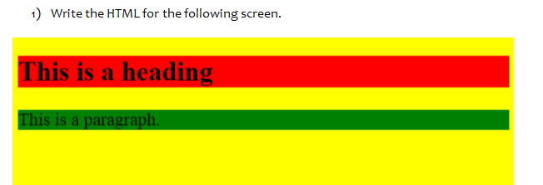

<html>

    <head >

        <style>

            h1

            {

                    background-color: red;

            }

            h3

            {

                    background-color: green;

            }

        </style>

    </head>

    <body style="background-color: yellow">

        <h1>This is a heading</h1><br>

        <h3>This is a paragraph.</h3>

    </body>

</html>

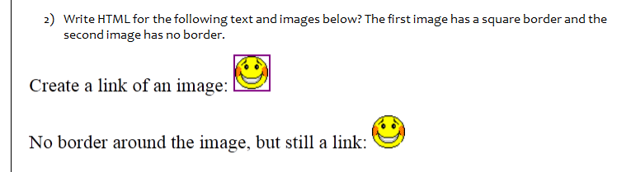

<html>

    <head>

    </head>

    <body>

        <p>Create a link of an image:<img src="image/smiley.png" width="30" height="30"></p>

        <p>No border around the image, but still a link:<img src="image/smiley.png" width="30" height="30"></p>

    </body>

</html>

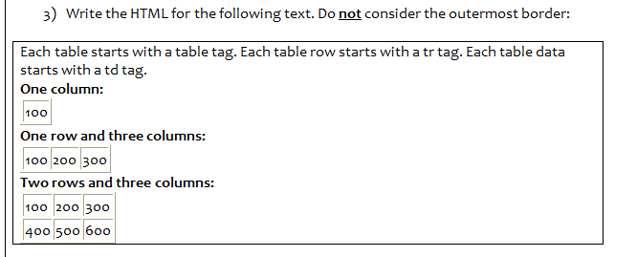

<html>

    <head>

        <style>

            td

            {

                border: 1px solid black;

            }

        </style>

    </head>

    <body>

        <p><b>One column:</b></p>

        <table>

            <tr>

                <td>

                    100

                </td>

            </tr>

        </table>

        <p><b>One row and three columns:</b></p>

        <table>

            <tr>

                <td>

                    100

                </td>

                <td>

                    200

                </td>

                <td>

                    300

                </td>

            </tr>

        </table>

        <p><b>Two row's and three columns:</b></p>

        <table>

            <tr>

                <td>

                    100

                </td>

                <td>

                    200

                </td>

                <td>

                    300

                </td>

            </tr>

            <tr>

                <td>

                    400

                </td>

                <td>

                    500

                </td>

                <td>

                    600

                </td>

            </tr>

        </table>

    </body>

</html>

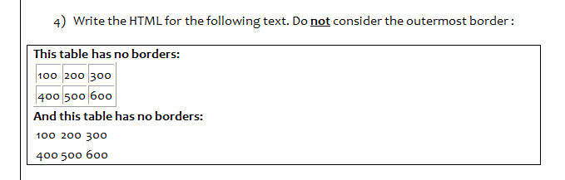

<html>

    <head>

    </head>

    <body>

        <p><b>This table has borders:</b></p>

        <table>

            <tr>

                <td style="border: 1px solid black;">

                    100

                </td>

                <td style="border: 1px solid black;">

                    200

                </td >

                <td style="border: 1px solid black;">

                    300

                </td>

            </tr>

            <tr>

                <td style="border: 1px solid black;">

                    400

                </td>

                <td style="border: 1px solid black;">

                    500

                </td>

                <td style="border: 1px solid black;">

                    600

                </td>

            </tr>

        </table>

        <p><b>This table has no borders:</b></p>

        <table>

            <tr>

                <td>

                    100

                </td>

                <td>

                    200

                </td>

                <td>

                    300

                </td>

            </tr>

            <tr>

                <td>

                    400

                </td>

                <td>

                    500

                </td>

                <td>

                    600

                </td>

            </tr>

        </table>

    </body>

</html>

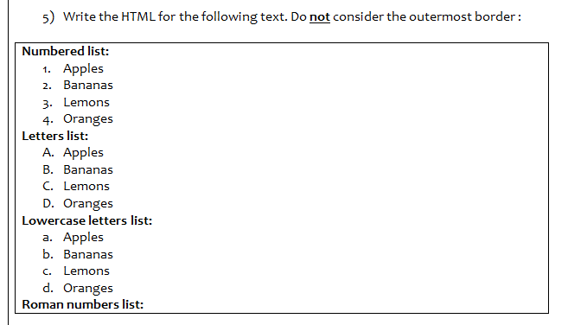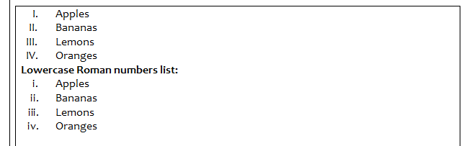

<html>

    <body>

        <p><b>Numbered list:</b></p>

        <ol>

            <li>Apples</li>

            <li>Bananas</li>

            <li>Lemons</li>

            <li>Oranges</li>

        </ol>

        <p><b>Letters list:</b></p>

        <ol type="A">

            <li>Apples</li>

            <li>Bananas</li>

            <li>Lemons</li>

            <li>Oranges</li>

        </ol>

        <p><b>Lowercase Letters list:</b></p>

        <ol type="a">

            <li>Apples</li>

            <li>Bananas</li>

            <li>Lemons</li>

            <li>Oranges</li>

        </ol>

        <p><b>Roman numbers list:</b></p>

        <ol type="I">

            <li>Apples</li>

            <li>Bananas</li>

            <li>Lemons</li>

            <li>Oranges</li>

        </ol>

        <p><b>Lowercase Roman numbers list:</b></p>

        <ol type="i">

            <li>Apples</li>

            <li>Bananas</li>

            <li>Lemons</li>

            <li>Oranges</li>

        </ol>

    </body>

</html>

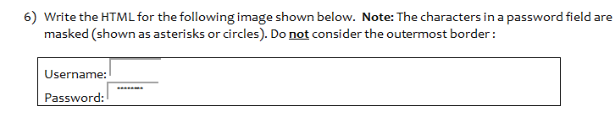

<html>

    <body>

        <label for="username">Username:</label>

        <input type="text" id="username"><br>

        <label for="pass">Password:</label>

        <input type="password" id="pass">

    </body>

</html>

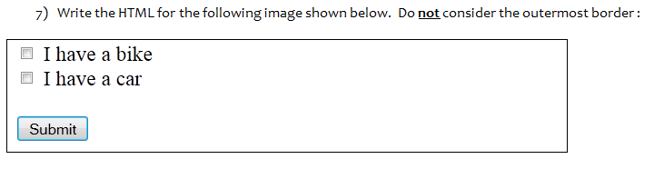

<html>

    <body>

        <input type="checkbox" name"I have a bike" value="I have a bike">I have a bike<br>

        <input type="checkbox" name"I have a car" value="I have a car">I have a car<br><br>

        <input type="submit" name="submit" value="submit">

    </body>

</html>

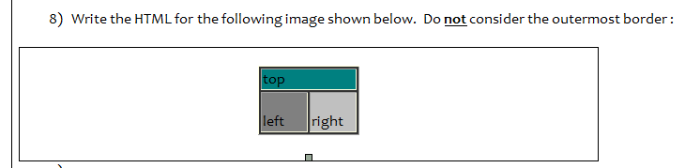

<html>

<head>

<style>

.item1 { grid-area: top; }

.item2 { grid-area: left; }

.item3 { grid-area: right; }

.grid-container {

  display: grid;

  grid-template-areas:

    'top top top top'

    'left left right right'

    'left left right right';

  grid-gap: 1px;

}

.item1

{

    background-color:darkgreen;

}

.item2

{

    background-color:gray;

}

.item3

{

    background-color:darkgrey;

}

.grid-container > div {

  border: 1px solid black;

  padding: 1px 0;

  font-size: 20px;

}

</style>

</head>

<body>

<div class="grid-container">

  <div class="item1"> top</div>

  <div class="item2">left</div>

  <div class="item3">right</div>

</div>

</body>

</html>

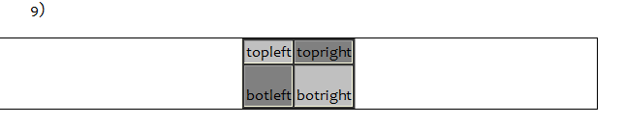

<html>

<head>

<style>

.item1 { grid-area: topleft; }

.item2 { grid-area: topright; }

.item3 { grid-area: botleft; }

.item4 { grid-area: botright; }

.grid-container {

  display: grid;

  grid-template-areas:

    'topleft topleft topright topright'

    'botleft botleft botright botright'

    'botleft botleft botright botright'

    'botleft botleft botright botright';

  grid-gap: 1px;

}

.item1

{

    background-color:darkgrey;

}

.item2

{

    background-color:grey;

}

.item3

{

    background-color:grey;

}

.item4

{

    background-color:darkgray;

}

.grid-container > div {

  border: 1px solid black;

  padding: 1px 0;

  font-size: 20px;

}

</style>

</head>

<body>

<div class="grid-container">

  <div class="item1">topleft</div>

  <div class="item2">topright</div>

  <div class="item3">botleft</div>

  <div class="item4">botright</div>

</div>

</body>

</html>